|  |  |
| --- | --- |
| Date | 20th April 2023 |
| Team ID | NM2023TMID05572 |
| Project Name | Build a Employee Travel Approval Application for Corporate |
| Team Leader | SOWMIYA.J |
| Team Member | OVIYAVARTHINI.G |
| AKALYA.K |
| GOKULRAJ.P |

**BUILD A EMPLOYEE TRAVEL APPROVAL APPLICATION FOR CORPORATES**

1. **INTRODUCTION**
   1. **Overview**

The project aim is to provide real time knowledge for all the students who have basic knowledge of sale force and looking for a real – time project.

* 1. **Purpose**

Travel request from are designed to given management an overview of the intended business trip form both a cost and a strategic point of view.

Empathy Map

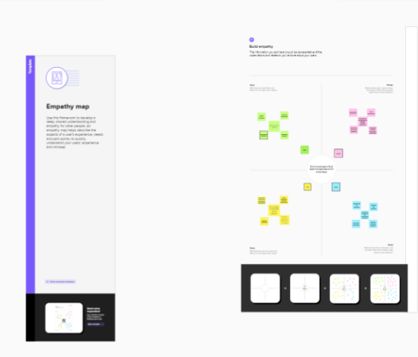

Brainstorming Map

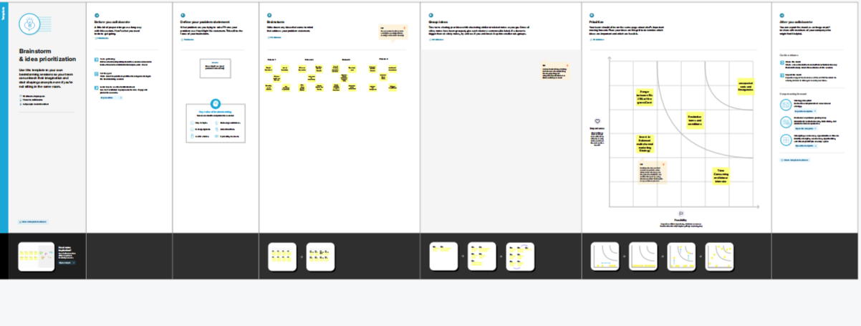

1. **RESULT**

**3.1 Data Model**

|  |  |  |
| --- | --- | --- |
| Object Name | Fields in the object | |
| Field Label | Data Type |
| Travel Approval Request | Status | URL |
| Technical Site | URL |
| Description | URL |
| Travel Approval URL | URL |
| Phone Number | Phone |
| Review | - | - |

3.2 Activity & Screenshot

Milestone 1:

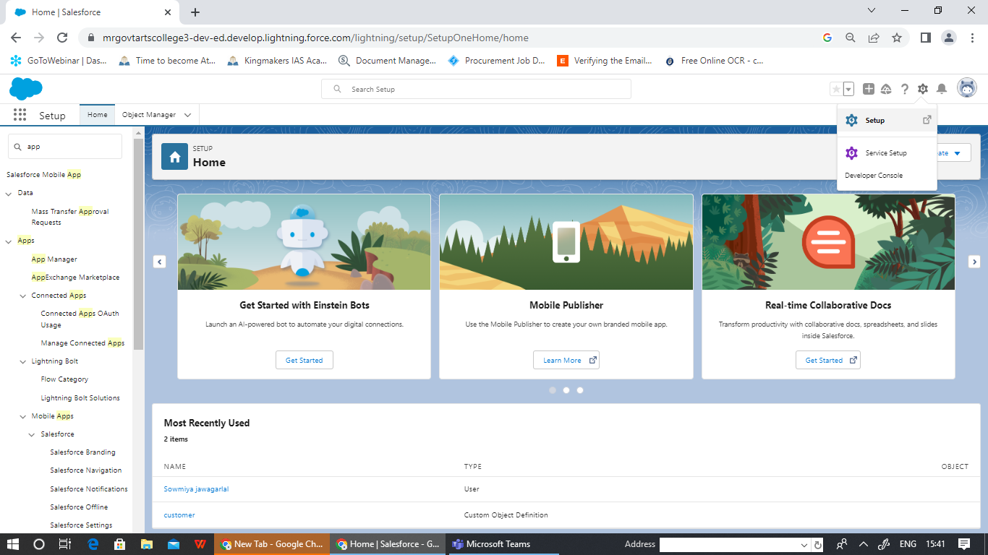

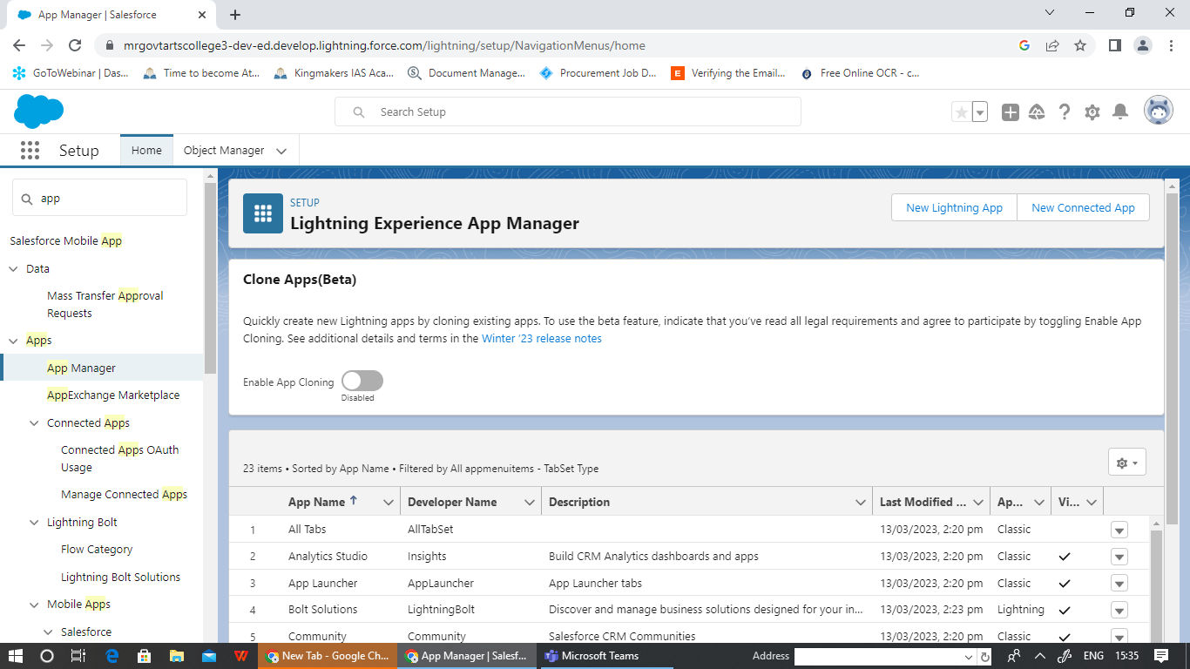

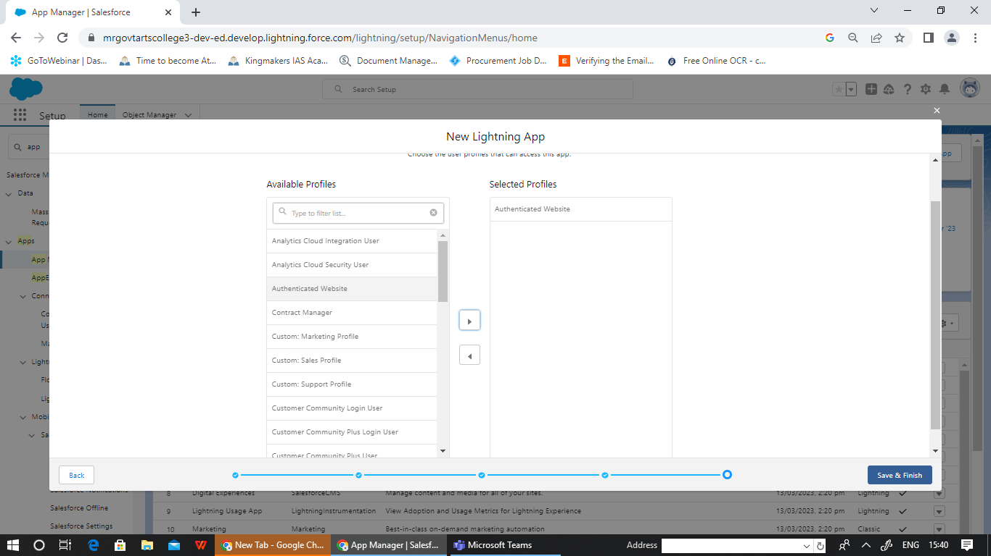

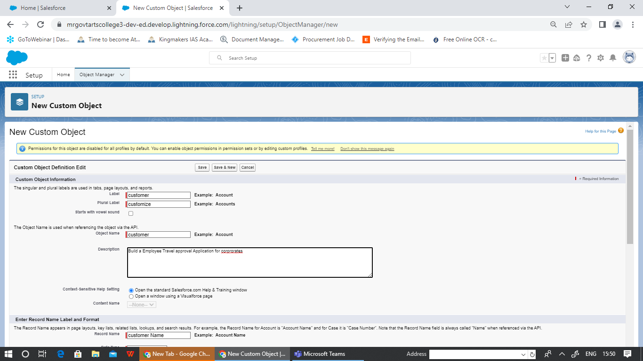

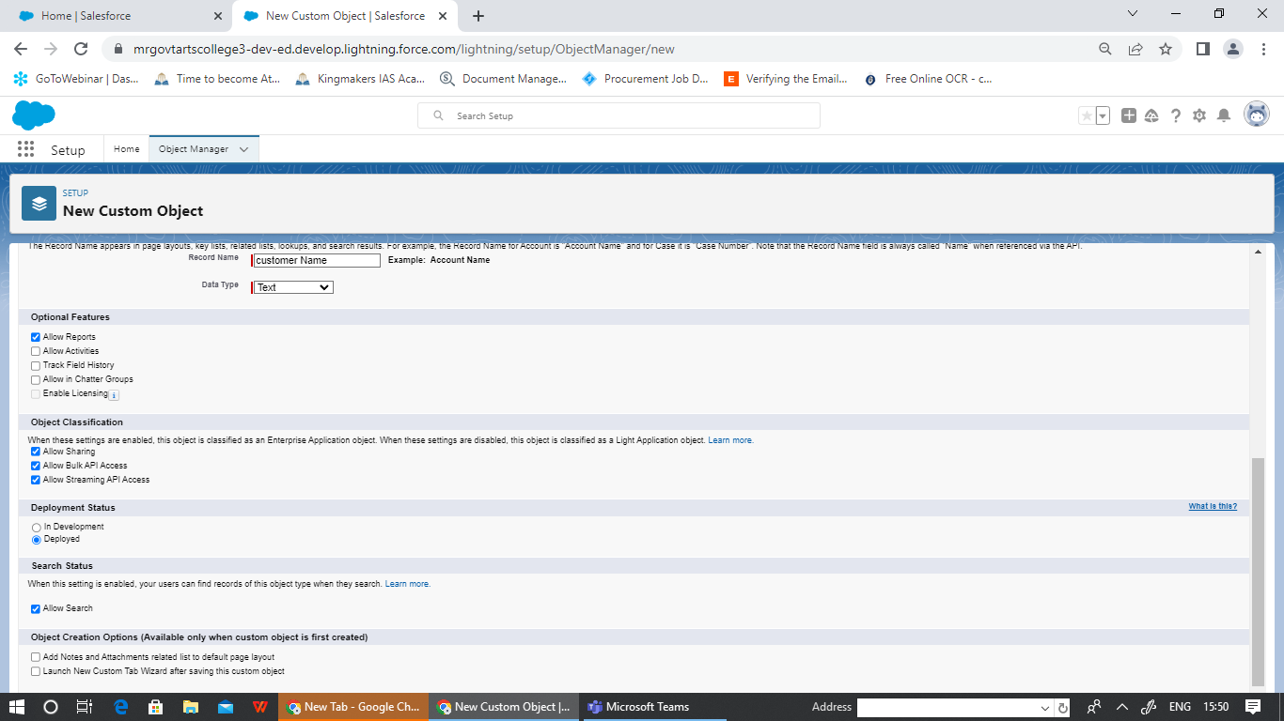

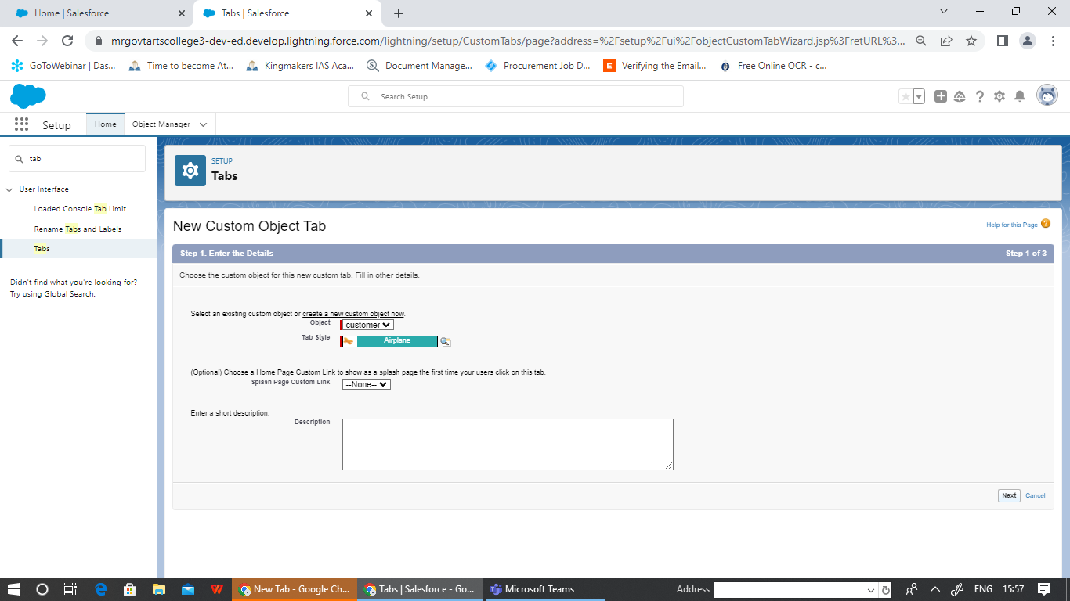 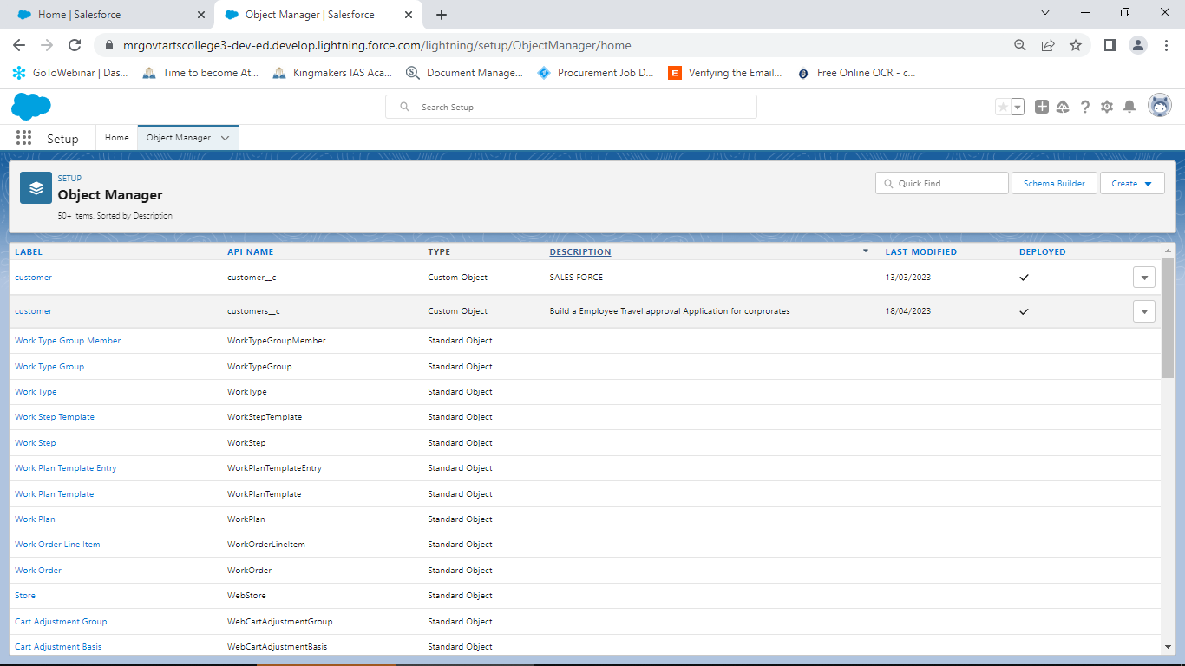 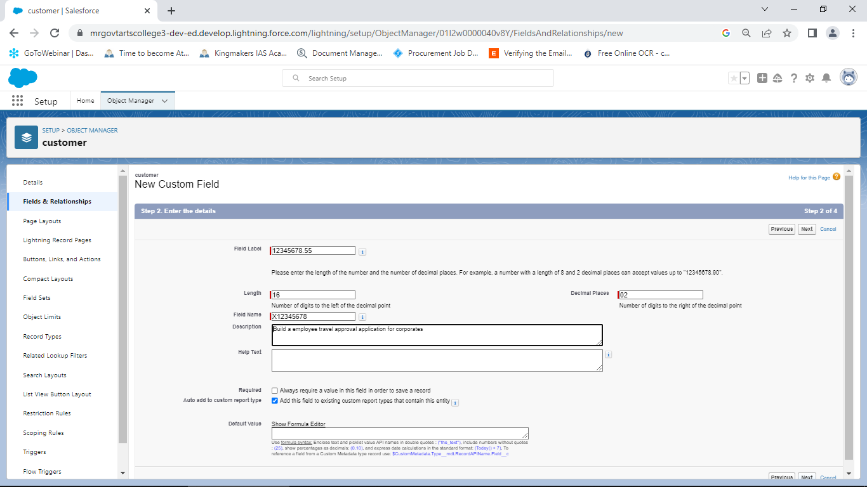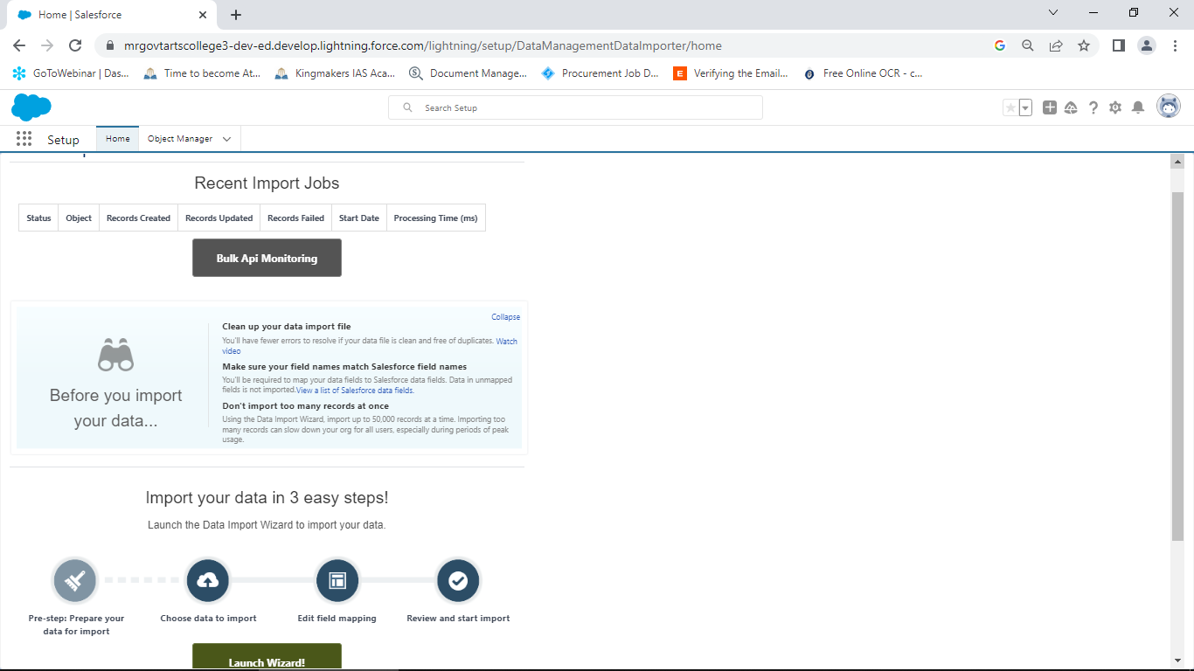 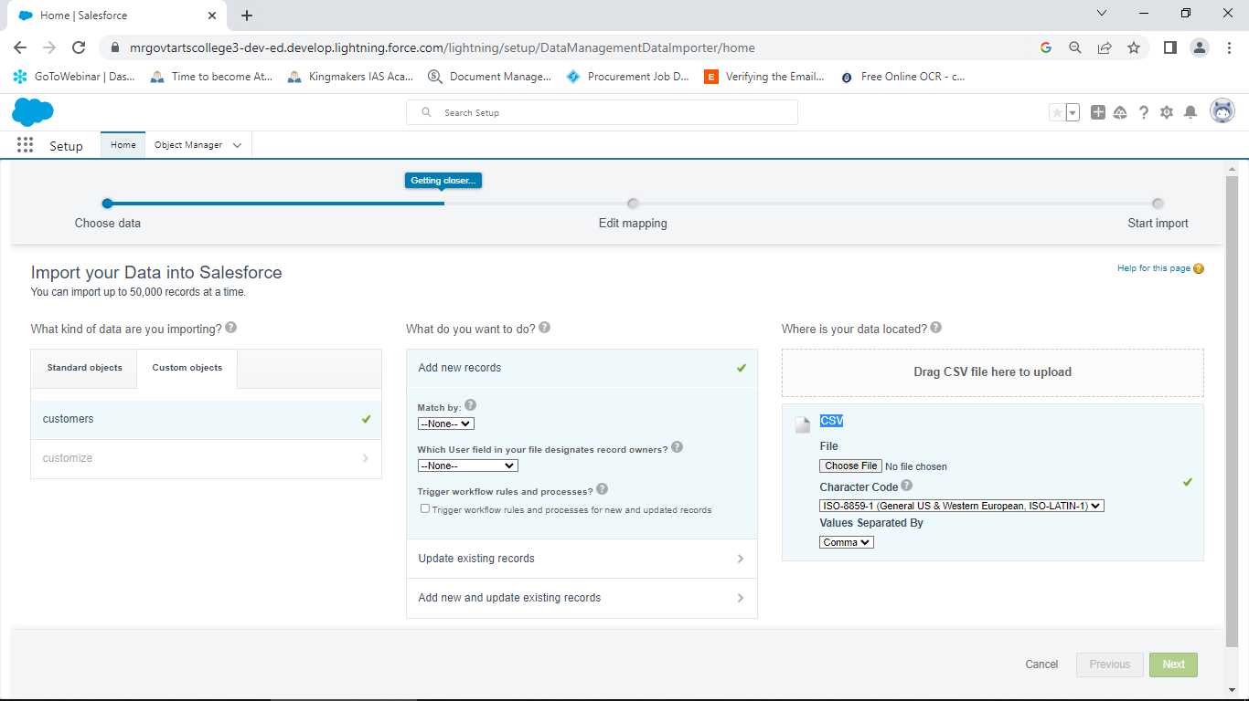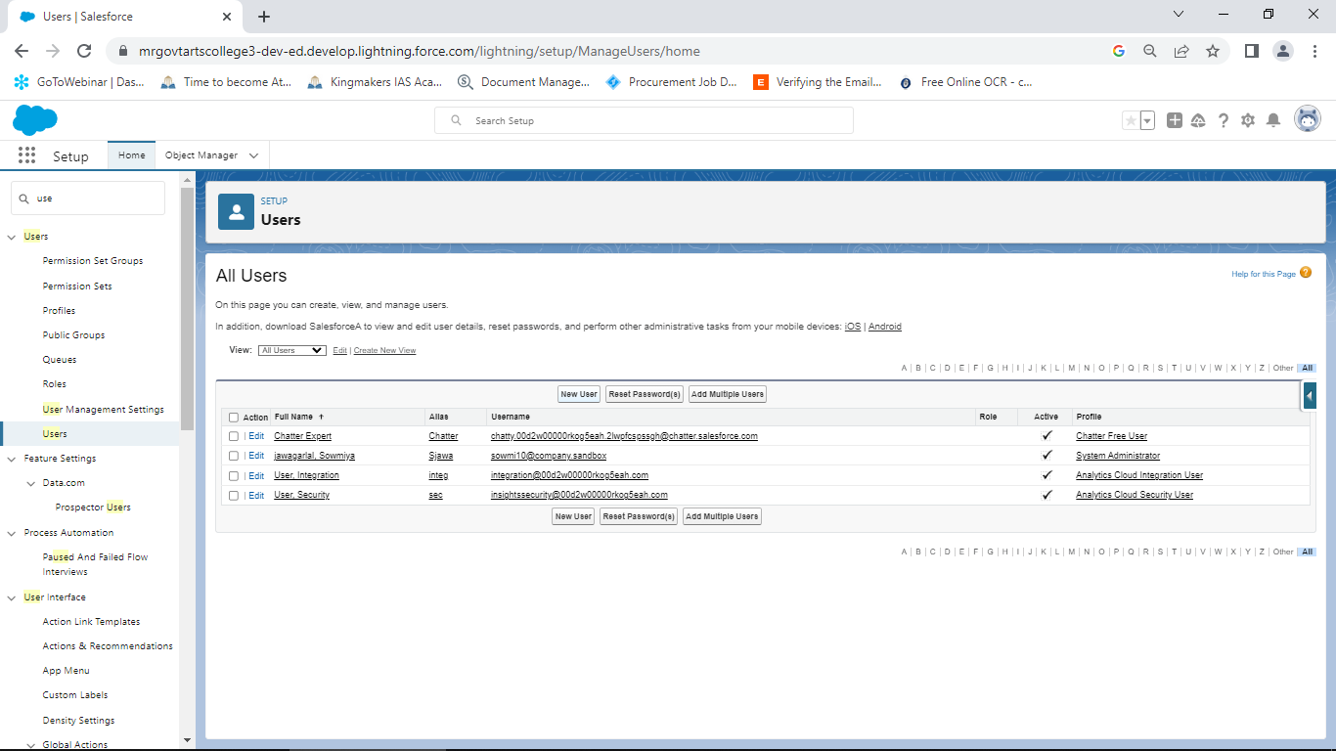 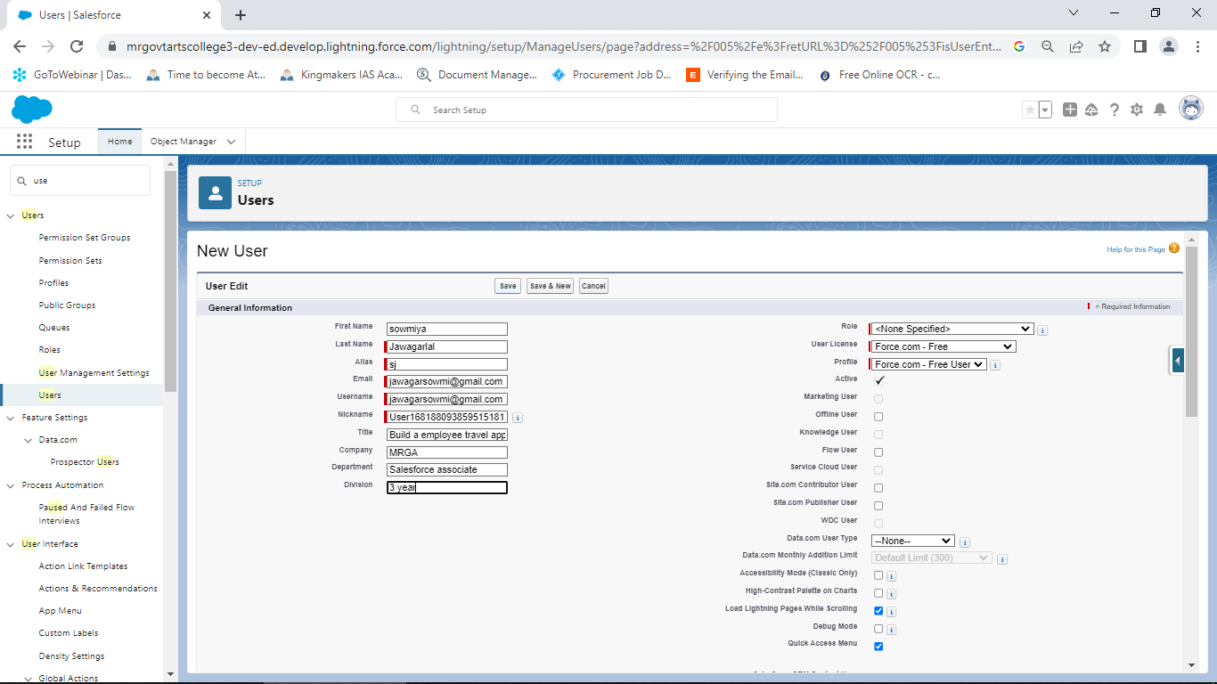 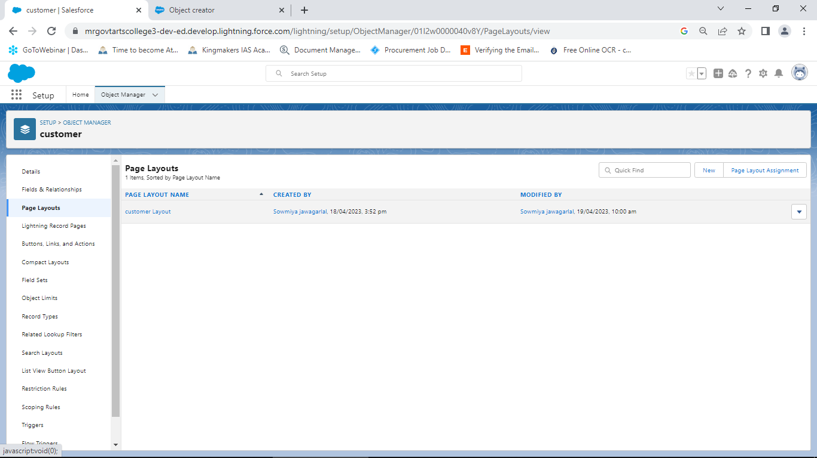

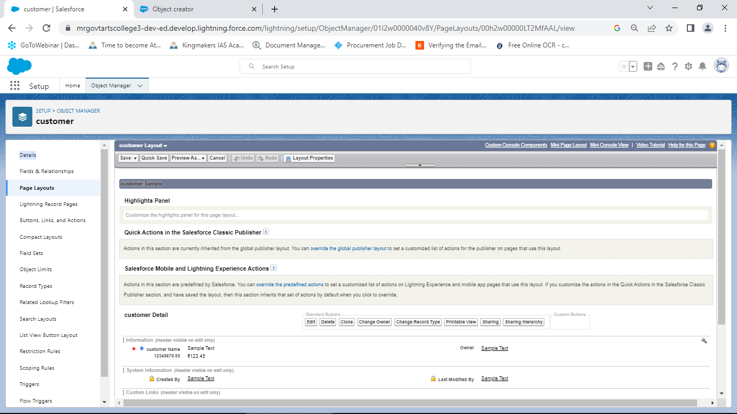

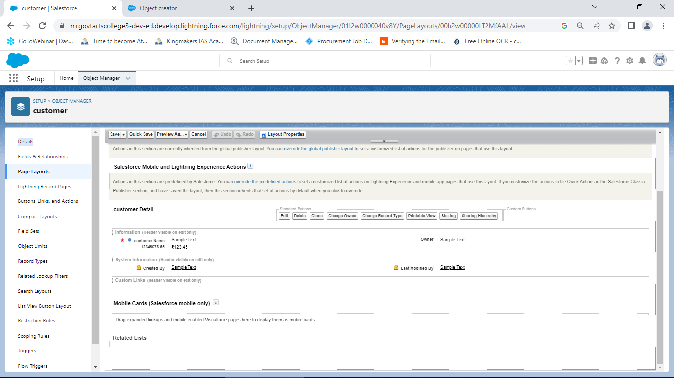

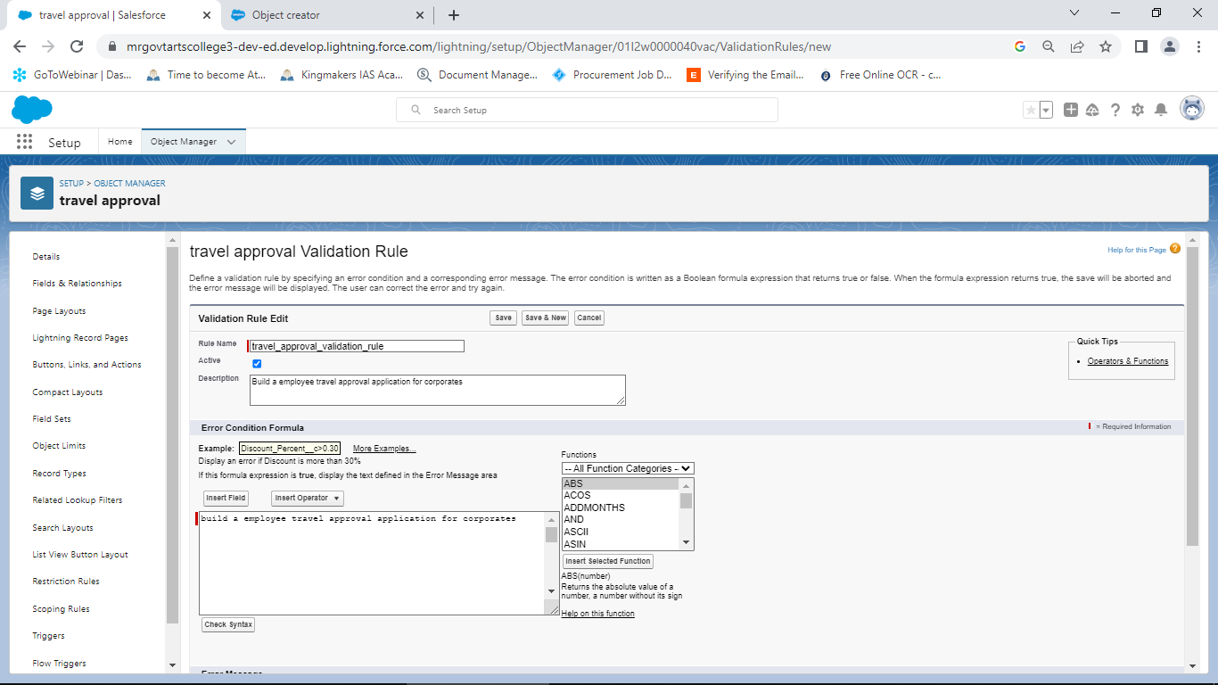

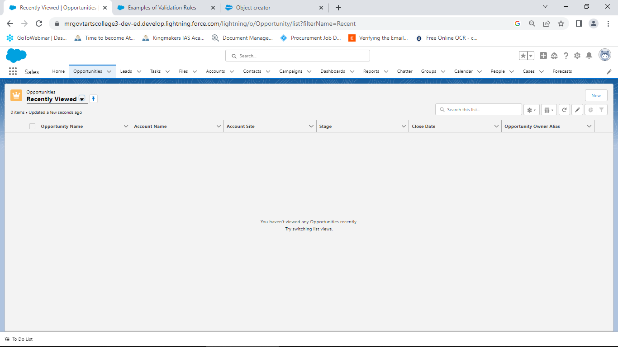

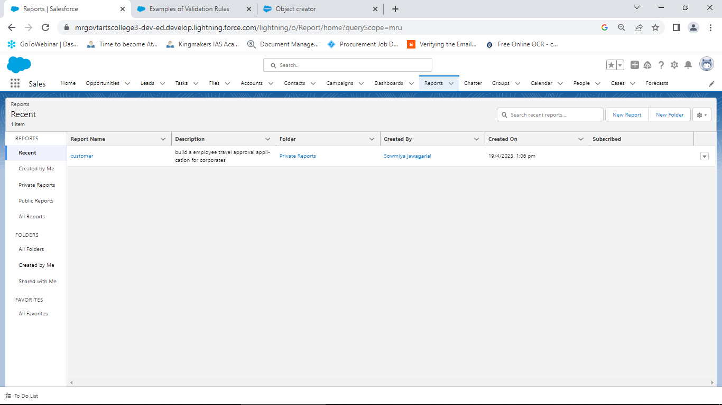

**4 TRAVELHEAD PROFILE PUBLIC URL**

Team Leader - <https://traiblazer.me/id/sjawagarlal>

Team Member 1 - <https://traiblazer.me/id/ogowriraj>

Team Member 2 - <https://traiblazer.me/id/akaliyappan>

Team Member 3 - <https://traiblazer.me/id/gpathmaraj>

1. **ADVANTAGES & DISADVANTAGES**

* Approvals on time
* Customize approvals workflows
* Increase compliance and reduce costs
* Faster Process
* It is not easy to manage expense with a traditional expense approval process where spread sheets and emails are used.
* Things are slow in a manual expense approval process.

1. **APPLICATION**

The travel support system allows uou to request and approve business trip.

1. **CONCLUSION**

This project helps in sending your travel approval requests to your manager in place of emails view curriculum project description project description.

1. **FUTURE SCOPE**

The Possibilities and scope for the application of machine hearing in travel are endless.